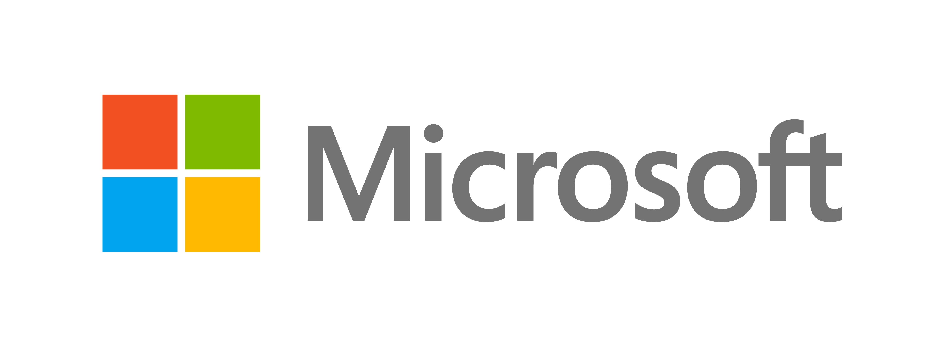

**Employee Information Supplement  
Stock Awards**

**CANADA**

|  |
| --- |
| **Overview** |
| This supplement has been prepared to provide you with a summary of the tax consequences and certain other issues associated with the grant of Stock Awards (“SAs”) [1] by **Microsoft Corporation** (the “Company”) under the **2017 Stock Plan** (the “Plan”).  This supplement is based on the tax laws in effect in your country as of **December 2022**.  Tax laws often are complex and can change frequently. As a result, you should consult with your personal tax advisor for current information and further guidance regarding your personal tax liabilities and responsibilities associated with the grant of your SAs, the vesting of your SAs and issuance of Company shares, the payment of any dividends on such shares, and the sale of Company shares acquired under the Plan.  Please note that this supplement is general in nature and does not discuss all of the various laws, rules and regulations that may apply. It may not apply to your particular tax or financial situation, and the Company is not in a position to assure you of any particular tax result. The information in this supplement assumes that the SAs will be settled in shares and that the shares will be issued as soon as administratively practicable following the date of vesting. If any dividends are paid on shares, it is assumed that the dividends will be paid into an offshore brokerage account (*i.e.,* they will not be paid by a bank in your country or into an account in your country). **You should consult with an appropriate professional advisor as to how the tax or other laws in your country apply to your specific situation.**  If you are a citizen or resident of another country or transfer employment and/or residency after SAs are granted to you or if you are no longer actively employed at the time of the taxable event, the information contained in this supplement may not be applicable to you.  Finally, the information in this supplement assumes that you are not a U.S. tax resident and that you have completed a Form W-8BEN to certify your status as a non-U.S. person. |

|  |
| --- |
| **This document constitutes part of a prospectus covering securities that have been registered with the U.S. Securities and Exchange Commission under the U.S. Securities Act of 1933, as amended.** |

| **IMPORTANT INFORMATION** |
| --- |
| **Securities Notification**: In addition to any other applicable restrictions on resale and transfer, shares purchased under the Plan may be subject to certain restrictions on resale imposed by Canadian provincial securities laws. You are permitted to sell shares acquired pursuant to the Plan through the designated broker appointed under the Plan, provided the sale of the shares acquired pursuant to the Plan takes place outside of Canada through the facilities of a stock exchange on which the shares are listed.  **Tax Notification**: You are hereby by notified that the SAs are non-qualified awards for Canadian tax purposesand therefore are not eligible for the 50% tax deduction that may apply to income from stock options. |

|  |  |
| --- | --- |
| **Tax** | |
| **Grant** | No taxation. |
| **Vesting** | On the date(s) the SAs vest and you acquire shares, you will be subject to taxation. |
| *Taxable Amount* | The fair market value of the shares on the date of vesting. As noted above, the 50% tax deduction does not apply to SAs. |
| *Nature of Taxable Amount* | Employment compensation. |
| *Is Income Tax Payable?* | Yes. |
| *Are Employee Social Insurance Contributions Payable?* | Yes, you will be subject to Canada Pension Plan (“CPP”) contributions (or Quebec Pension Plan (“QPP”) contributions, if you reside in Quebec), on the taxable amount (to the extent the applicable contribution ceiling has not been exceeded). |
| *Are Other Taxes Payable?* | No. |

|  |  |
| --- | --- |
| **company/employer tax withholding and reporting** | |
| **Withholding** | |
| *Is Income Tax Withheld?* | Yes. |
| *Are Employee Social Insurance Contributions Withheld?* | Yes (to the extent the applicable contribution ceiling has not been exceeded). |
| *Are Other Taxes Withheld?* | Not applicable. |
| **Reporting** | |
| *Does the Taxable Amount Need to be Reported?* | Your employer will report the taxable amount as taxable income to the Canada Revenue Agency (“CRA”) on Form T4 and if applicable, to Revenu Quebec (“RQ”) on Form RL-1. A copy of Form T4 (Form RL-1) will be provided to you by the end of February of the year following the year in which the taxable event occurs. |

|  |  |
| --- | --- |
| **DIVIDENDS** | |
| **Taxation in Your Country** | If you acquire shares and a dividend is subsequently declared on the Company’s shares, any dividends paid with respect to the shares will be subject to tax in your country. |
| **Taxation in the U.S.** | Further, any dividends paid will be subject to United States (“U.S.”) federal tax withholding at source. You may be able to claim a reduced rate of U.S. federal tax withholding on such dividends as a resident of a country with which the U.S. has an income tax treaty. You must have a properly completed U.S. Internal Revenue Service Form W-8BEN on file with the broker with which your Company shares are deposited in order to claim the treaty benefit. You also may be entitled to a tax credit in your country for the U.S. federal tax withheld at source. *You should consult with your personal tax advisor regarding the availability of such a credit.* |

|  |  |
| --- | --- |
| **SALE OF SHARES** | |
| **Taxation in Your Country** | When you subsequently sell any shares acquired under the Plan, you will be subject to additional taxation on any gain you realize. The taxable amount will generally be one-half (50%) of the difference between the sale proceeds and the adjusted cost base (“ACB”) of your shares. If you do not own (and have never owned) other shares of the Company the ACB will generally be the fair market value of the shares on the date of acquisition. However, if you own (or have owned) other Company shares acquired inside and/or outside of the Plan, your ACB will generally be the average cost of all of your Company shares of the same class.  If your sale proceeds are lower than your ACB of the shares sold, you will generally realize a capital loss. One-half (50%) of any capital loss may be used to offset taxable capital gains in the same calendar year, the three (3) preceding calendar years, or in subsequent years, but cannot be used to offset other types of income (*e.g.*, salary/wages).  *You should consult your personal tax advisor for additional information regarding the calculation of any gain or loss attributable to the sale of your shares and to consider the alternatives available to you.* |
| **Taxation in the U.S.** | Assuming you are not a U.S. tax resident and have provided the Company and/or the broker with a Form W-8BEN to certify your status as a non-U.S. person, you will not be subject to tax in the U.S. on any gain you realize when shares acquired under the Plan are sold. If you have not provided a Form W-8BEN, the broker will perform U.S. back-up withholding on the gain at a rate of 24%. |

| **YOUR tax REPORTING and payment OBLIGATIONS** | |
| --- | --- |
| **Vesting** | You must report the taxable amount on your Canadian T1 personal income tax return (and Quebec TP-1-V personal income tax return, if you reside in Quebec) and pay any additional tax owed by April 30 of the following year. |
| **Dividends** | You must report the dividends on your Canadian T1 personal income tax return (and Quebec TP-1-V personal income tax return, if you reside in Quebec) and pay any tax owed by April 30 of the following year. |
| **Sale of Shares** | You must report the gain (or loss) on your Canadian T1 personal income tax return (and Quebec TP-1-V personal income tax return, if you reside in Quebec) and pay any tax owed by April 30 of the following year. |

|  |  |
| --- | --- |
| **Other Information** | |
| **Foreign Asset/Account Reporting** | Specified foreign property, including shares acquired under the Plan and certain awards granted under the Plan, must be reported on Form T1135 (Foreign Income Verification Statement) if the total cost of such foreign property exceeds CAD 100,000 at any time during the year.  If the CAD 100,000 cost threshold is exceeded by other specified foreign property held, your awards must be reported as well, generally at a nil cost. When Company shares are acquired, their cost generally is the ACB of the shares.  The Form T1135 must be filed by April 30 of the following year. *You should consult with your personal tax advisor for further details regarding this requirement*. |
| **Exchange Control** | None. |
| **U.S. Estate Tax** | You should be aware that U.S. estate tax may be assessed at the time of death if you hold Company shares (and certain awards) at this time.  U.S. estate tax law requires that, for the estates of non-U.S. citizens who reside outside the U.S. (“non-resident aliens“), an estate tax return must be filed if the gross estate exceeds USD 60,000, though if an estate tax treaty applies, the consequences will differ.  The gross estate of a non-resident alien consists only of assets located in the U.S., which will include your Company shares (and certain awards granted under the Plan).  *Due to the complexity of these laws, your heirs should consult with a personal tax or financial advisor.* |

1. SAs are an unfunded, unsecured promise to issue Company shares at no cost to you at a later time. 